THEME 1 STUDYING ABROAD-YURTDIŞINDA OKUMAK
GREETING(SELAMLAŞMA)
MEETING PEOPLE(İNSANLARLA TANIŞMA)
Hello = Hi (=very informal) -Merhaba
Hello. I’m Ümit / Hi. I’m Aslı. /
My name is Belma.(Adım Belma)/
Hi. My name is Betül.(Selam,benim adım Aslı.)
Good Morning (Günaydın) Good Afternoon(Tünaydın)
Good Evening(İyi akşamlar) Good Night(İyi geceler)

BANU: Hi. I’m Banu. What is your name?(Selam,ben Banu.Senin adın ne?)
BRIAN: Hello. My name’s Brian.(Merhaba,adım Brian)
BANU: Nice to meet you (Tanıştığıma memnun oldum.)
BRIAN: Nice to meet you too.(Ben de memnun oldum)
Nice to meet you = Glad to meet you = Pleased to meet you.= How do you do =TANIŞTIĞIMA MEMNUN OLDUM

LEAVING PEOPLE ( VEDALAŞMA)
FORMAL : Goodbye(Güle güle)
INFORMAL: Bye /see you(Görüşürüz)/see you later(Sonra görüşürüz)/see you tomorrow(yarın görüşürüz)
Cheers(Hoşçakal) / Take care(kendine iyi bak)

ASKING ABOUT HEALTH (SAĞLIĞINI SORMA)
How are you?(Nasılsın?)
Fine, thank you. = Fine, thanks.(İyiyim teşekkürler.)

Informal (Resmi olmayan)
How are things? How’s things? -How’s it going? -How are you doing/going(USA) =Nasıl gidiyor?
Great-Harika Not too bad-Fena sayılmaz. OK/All right-iyidir so-so –İdare eder

THANK YOU
Formal: Thank you very much / Thank you very much indeed /
Informal: Thanks / Thanks a lot

Replıes to thanks(Teşekkür edildiğinde verilecek cevaplar)
A: Thanks A: Thank you very much for tea. A: Thank you. A: Thanks a lot.
B: That’s Ok(all right)-Tamam B: Not at all (formal)-Rica ederim B: You are welcome.-Rica ederim B: Don’t mention it.-Rica ed.

CLASSROOM ENGLISH(Sınıf İngilizcesi)
Instructions:
Listen -Dinle/ Repeat after me-tekrarla / Come here-buraya gel / Open your books/notebooks –kitaplarınızı/defterlerinizi açın/
Close your books-kitaplarınızı kapatın / Write this into your notebooks-Bunları defterlerinize yazın.
Learn this by heart -ezberleyin/ Do your homework –ödevinizi yapın/ Look here-Buraya bakın / Fill in the blanks-Boşlukları doldurun
Read the text silently-parçayı sessizce okuyun / Work in pairs-ikili çalışın / Ask a question-soru sorun/Answer the question –Soruyu cevaplayın/ Look at the board-Tahtaya bakın / Don’t read -Okumayın/ Read a lot –Çok okuyun/ Practice a lot-alıştırma yapın / Revise your notes-yazdıklarınızı tekrar edin

Discipline:
Be quiet, please –Lütfen sessiz olun/ Speak English-İngilizce konuşun. / Stand up-ayağa kalkın / Sit down-oturun / Put your fingers up-parmak kaldırın / Put your fingers down-parmaklarınızı indirin / No talking-konuşmak yok / Sit back-arkaya yaslanın
Open/Close the window-pencereyi açın-kapatın / Don’t run in the class-sınıfta koşmayın / Don’t miss classes-dersi kaçırmayın /
Don’t be late for school-okula geç kalmayın
Feedback and encouragement:
Good.-İyi / Very good –Çok İyi/ Excellent-Mükemmel / Well done -Aferin/ Thank you –Tşk./Try again-Tekrar dene

THE PRESENT TENSE OF THE VERB ‘’TO BE’’
Am Is Are Konu Anlatımı :Genel anlamda “to be” yardımcı fiili; herhangi bir durum, statü, konum veya zamanı ifade etmek için kullanılır. Yardımcı Fiil Kullanımı: Olumlu cümlelerde yardımcı fiil (am/is/are) özneden hemen sonra gelir. Olumsuz cümlelerde yardımcı fiilden hemen sonra “not” eki gelir. Soru cümlelerinde ise önce soru kelimesi (varsa), ardından yardımcı fiil ve hemen sonrasında özne gelir.
Singular subject pronouns–(Tekil Şahıs Zamirleri) : I – YOU – HE – SHE – IT
Plural Subject Pronouns –(Çoğul Şahıs Zamirleri) : WE – YOU – THEY
Singular Nouns –Tekil İsimler : Ali , Ayşe , Mr. Green , Miss. Kaplan , a tree , a computer
Plural nouns -Çoğul İsimler : Ali and Ahmet , trees , cars , computers

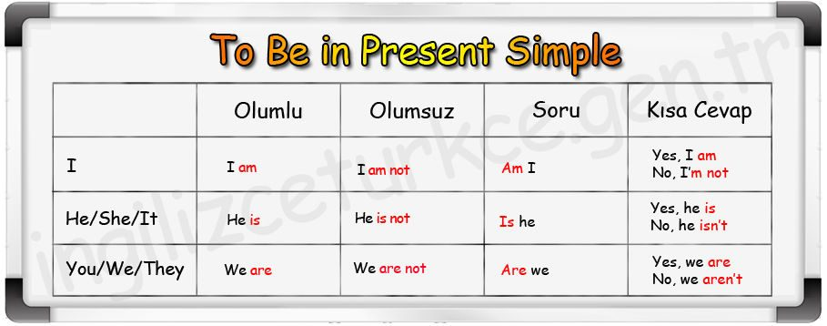
1.AFFIRMATIVE -OLUMLU
a) “ I” am ile kullanılır.
I am a worker .-Ben bir işçiyim I am not an engineer .-Ben mühendis değilim.
b) He,she ,it ve tekil özneler “is” alır.
He is a teacher –O bir öğretmen. She is a model –O bir manken Hülya Avşar is a singer-Hülya A. bir şarkıcı
c) We ,you,they ve çoğul özneler “are” alır.
Ali and Veli are friends .-Ali ve Veli arkadaşlar. -We are computer engineers-Biz bilgisayar mühendisiyiz.

2. NEGATIVE –OLUMSUZ
I’m not….
He-She-It isn’t…..
We-You-They aren’t……
I am not a doctor = I’m not a doctor -Doktor değilim
You are not in the garden = You aren’t in the garden-Bahçede değilsin
He is not happy = He isn’t happy-O, mutlu değil
She is not a musician = She isn’t a musician-O,müzisyen değil
It is not a pencil . = It isn’t a pencil-O bir kalem değil
We are not sad = We aren’t sad-Üzgün değiliz
They are not at home. = They aren’t at home.-Onlar evde değiller

3. INTERROGATIVE-SORU :
Am I your friend? Yes , you are / Yes , you are my friend.
Ben senin arkadaşın mıyım? No , you aren’t / No , you aren’t early
Are you from İzmir ? Yes , I am / Yes , I am from İzmir.
İzmirli misin? No, I am not / No , I am not from İzmir .
Is she at home ? Yes , she is / Yes , she is at home
O evde mi? No, she isn’t / No , she isn’t at home .
Is he a doctor ? Yes , he is / Yes , he is a doctor .
O bir doctor mu? No , he isn’t / No , he isn’t a doctor .
Is this a pen ? Yes , it is . / Yes , it is a pen .
Bu bir kalem mi? No , it isn’t / No , it isn’t a pen .
Are we late ? Yes , we/you are / Yes , we/you are late .
Geç kaldık mı? No , we/you aren’t / No , we/you aren’t late .
Are they in the class ? Yes , they are / Yes , they are in the class .
Onlar sınıftalar mı? No , they aren’t / No , they aren’t in the class .

4. INFORMATION QUESTIONS –BİLGİ SORULARI
WHO , WHOSE , WHERE , WHICH , WHAT , WHEN , WHY , HOW ...... etc
Questions with WHAT
What is your name ? -Adın ne?
QUESTIONS WITH WHO
Who are they ? - Onlar kim?
QUESTIONS WITH HOW
How is the weather ?- Hava nasıl?
QUESTIONS WITH WHERE
Where are the children ? -Çocuklar nerede?
QUESTIONS WITH WHICH
Which book is yours ?-Hangi kitap senin?

EXERCISES
A. Fill in am, is, are, am not, isn’t or aren’t.
1. A : Where______ Carlos from?
B : He _____ from Italy.
2. A : _____ you from Brazil?
B : No, I _______. I _____ from Spain.
3. A : _____ they Greek?
B : Yes, they _____.
4. A : ____ she your sister?
B : No, she _______
5. A : Your friends ______ students at a school of tourism, aren’t they?
B : No, they _________
B. Put the words in the correct order.
1. you / a / student / university / _____________________________________________________
2. sister / My / old / years / is / nineteen _______________________________________________
3. is / English / subject / my / favourite _________________________________________________
4. isn’t / Matthew / Ireland / from _____________________________________________________.
5. room / Her / very / is / big ___________________________________________________________
6. you / in / class 9B / Are / your / and / friend __________________________________________________

SUBJECT PRONOUNS-Şahıs zamirleri

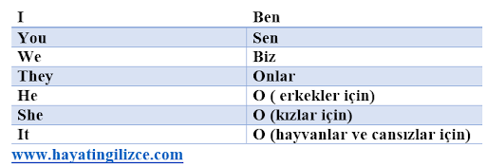
*Ahmet-He *Ece and Fatih-They
*Serap-She *The dogs-They
*My cat-It *The table-It
*The students-They *You and I-We

EXERCISES
A. Look at the words in brackets and complete the sentence with the correct subject pronoun.
1. _________ is watching TV. (George)
2. _________ is white. (the board)
3. _________ are on the wall. (the posters)
4. ________ are running. (the cats)
5. ________ are cleaning our rooms. (my sister and I)
6. _______ are riding his bike. (Tom and Susan)
7. _______ have got a dog. My dog’s name is Berry.
8. ______ is from Bristol. (Victoria)
9. ________ are in the garden. (the flowers)
10. Are ________ coming, Joe?

POSSESSIVE ADJECTIVES-İYELİK SIFATLARI(SAHİPLİK)
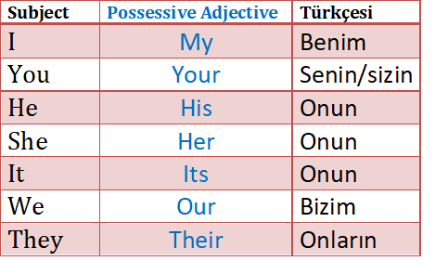
WHOSE
Genel olarak “whose ..?” sorusuna cevap verirken iyelik sıfatları kullanılır.
Whose car is this?-Bu kimin arabası It is my car.-O benim arabam.
Whose books are those?-Bu kitaplar kimin? Our books.-Bizim kitaplarımız
Whose birthday is in May?-Kimin doğum günü Mayıs’ta? My birthday. –Benim doğum günüm.

EXERCISES
A. Fill in the blanks with his, her, its, my, our, your, their.
1. Bill is my cousin. ________ bike is green.
2. Mike and Peter are Irish. _________ parents are teachers.
3. I am interested in movies. __________ favourite director is Steven Spielberg.
4. Linda is the new student. __________hair is red.
5. We are from Sweden. ___________classmates are French and Turkish.
6. You are tall but ___________brother is short.
7. My dog is so cute. __________ name is Dark.
B. Choose the correct answer.

1. My twin brothers ............... eighteen years old.
a) am b) is c) are
2. This is my friend Linda. ............... favourite sport is tennis.
a) Her b) She c) His
3. Look at Jill and Sue’s cat. ............... colour is white and grey.
a) It b) Its c) Their
4. Who is that with your brother? .............. best friend.
a) He b) His c) Her
5. My favourite subjects.............. History and Literature.
a) are b) is c) am

HAVE GOT / HAS GOT
have/has got Türkçe'de sahip olmak anlamındadır. Sahip olduğunuz bir şeyi ifade etmek için kullanılır. Aşağıda şahıslara göre nasıl kullanıldığını gösteren tablo verilmiştir.
OLUMLU YAPI / AFFIRMATIVE
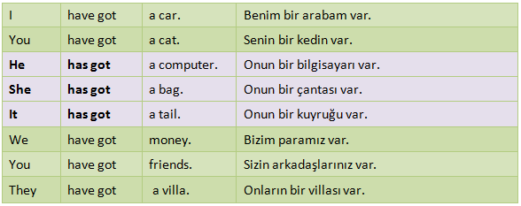

OLUMSUZ YAPI / NEGATIVE
Olumsuz yapıda ise ” have-haven’t , has-hasn’t ” şeklinde kullanılmaktadır. Tek yapmanız gereken ” n’t ” getirmek. Uzun yazılış ile ” have – has ” den sonra ” not ” getirmek. Bu kadar basit.
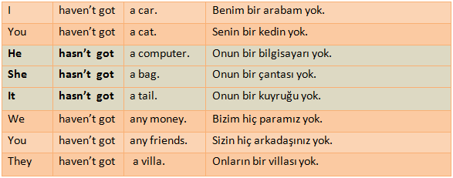

SORU YAPISI / INTERROGATIVE
Bu yapıda ise ” have , has ” cümle başına gelir. Gerisi aynen yazılır. İşte oldu , bu kadar.

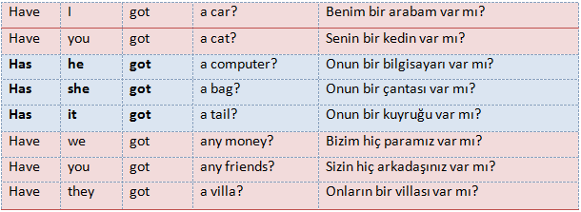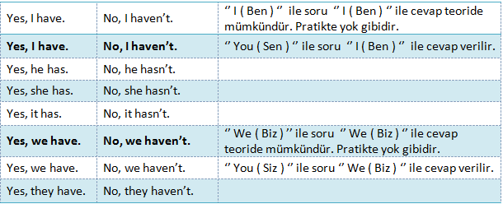

EXERCISES
A. Choose the correct option.
1. Have / Has Simon got a wardrobe in his room?
2. My grandparents have / has got a big house with a swimming pool.
3. Have / Has your twin sister got a laptop?
4. Sheila haven’t / hasn’t got a TV in her bedroom.
5. What have / has your sister got in her hand?
B. Put the words in the correct order.
1. got / has / Jane / camera / new / a _______________________________
2. Have / a / you / sister / got _______________________________
3. Sue / got / eyes / hair / blonde / has / and / green ______________________________________
4. you / got / new / a / phone / Have _________________________________________________
5. big / living room / My / have / a / got / grandparents ______________________________________

ASKING FOR DIRECTIONS ( YOL TARİFİ SORMA )
1. Nasıl Gideceğinizi Sorma Kalıpları
Excuse me, how can I go to .....? ( Özür dilerim, ......'e nasıl gidebilirim? )
Excuse me, where s the ......? ( Özür dilerm, ...... nerede? )
Excuse me, where s the nearest bank? ( Özür dilerim, en yakın banka nerede? )
Excuse me, can you tell me the way to the hospital? ( Özür dilerm, bana hastaneye nasıl gideceğimi söyler misiniz? )
2. Tarif Yapma Kalıpları
A. Düz Gitmek
Go along. ( Düz gidin / Boyunca gidin. )
Go straight. ( Düz gidin. )
Go straight ahead.( Düz gidin. )
Go / Walk down the street. (Sokaktan aşağıya doğru gidin / yürüyün. )
Go / Walk up the street. (Sokaktan yukarıya doğru gidin / yürüyün. )
B. Dönmek
Turn right: Sağa dönün
Turn left: Sola dönün
Take the first street on the left / right. ( Soldaki / sağdaki ilk sokaktan dönün. )
Take the second street on the left / right. ( Soldaki / sağdaki ikinci sokaktan dönün. )
Take the third street on the left / right. ( Soldaki / sağdak üçüncü sokaktan dönün. )
Turn right / left at the traffic lights. ( Trafik ışıklarında sağa / sola dönün. )
Turn left at the roundabout. ( Döner kavşaktan sağa / sola dönün. )
C. Geçmek
Cross the road. ( Caddeyi geçin. )
Pass the library. ( Kütüphaneyi geçin. )
D. Uzaklıktan Bahsetmek
Is it far from here? ( Buradan uzak mı? )
10 minutes by car/on foot. ( Arabayla / yaya 10 dakika )
5 minutes walk. ( 5 dakikalık yürüme mesafesinde. )
Just a few minutes on foot. ( Yürüyerek sadece birkaç dakika. )
It s very far away. I think you had better take a bus / take subway. ( Çok uzak.Bence en iyisi otobüse / metroya binin. )
E. Lokasyon Bildirmek
Over there, near the police station. ( Orada karakolun yanında. )
The school s on the right. ( Okul sağda. )
The cafe is on the left. ( Kafe solda. )
Between the post office and the cafe. ( Karakolla kafenin arasında. )
In front of the shopping centre. ( Alışveriş merkezinin önünde. )
Next to the car park. ( Otoparkın yanında. )

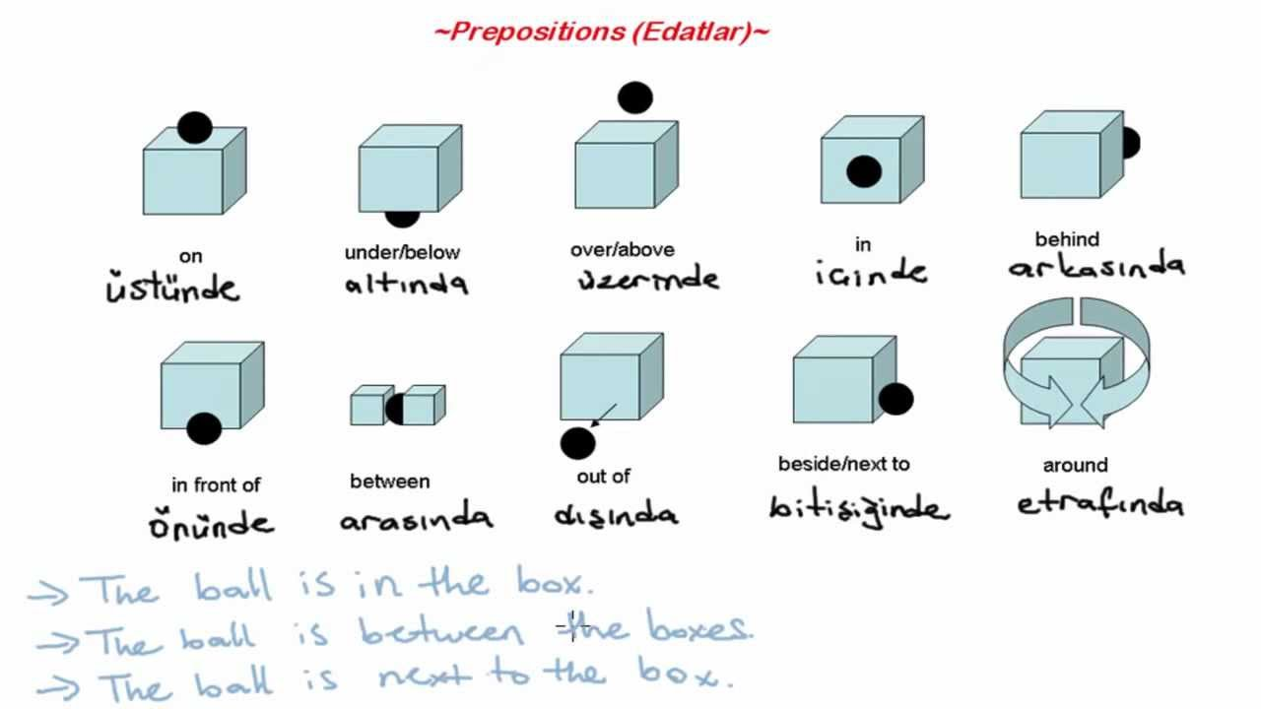

Look at the map ask questions and answer them
cinema | Lake Avenue  ***** | Post Office |  |  | News-agents |  |  | Video  Club
Serpent street | Lake Avenue  ***** | Oak Street
Green-  Grocer’s | Lake Avenue  ***** | Supermarket | St. Bernard  Str. |  | Chemist’s |  |  | BANK
Park street | Lake Avenue  ***** | Berkley Boulevard
Park | Lake Avenue  *****
Park | Lake Avenue  ***** | High school |  | library |  | mosque | Florist’s |  | Butcher’s
you are here
Family Members – Aile Bireyleri (Üyeleri)

Mother / Mum : Anne
Father / Dad: Baba
Child: Çocuk
Children: Çocuklar
Brother: Erkek kardeş
Sister: Kız kardeş
Grandmother / Grandma: Anneanne / Babaanne
Grandfather / Grandpa: Dede
Grandparents:Büyük anne-büyük baba
Daughter: Kız evlat
Son: Erkek evlat
Grandchild: Torun
Granddaughter: Kız torun
Grandson : Erkek torun
Cousin: Kuzen
Uncle: Amca, Dayı
Aunt: Hala , Teyze
Nephew: Yeğen (erkek)
Niece: Yeğen (kız)
Sister – in – law: Baldız
Brother-in-law: Kayınbirader
Father-in-law: Kayınpeder
Mother-in-law: Kaynana
Wife: Karı
Husband: Koca
Stepmother: Üvey anne
Stepfather: Üvey baba
Bride: Gelin
Bridegroom/ groom: Damat
Parents: Ebeveyn

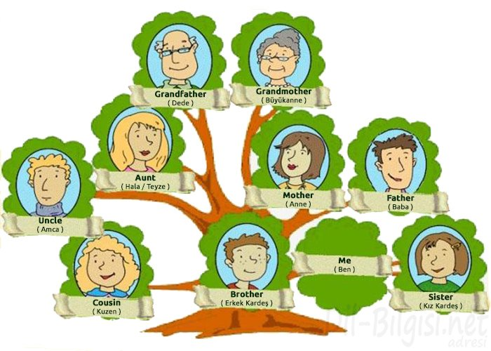

COUNTRIES-ÜLKELER NATIONALITIES-ULUSLAR
England – İngiltere |  | English – İngiliz
The United States of America (the USA) – Amerika Birleşik Devletleri (ABD) |  | American – Amerikalı
Mexico – Meksika |  | Mexican – Meksikalı
Canada – Kanada |  | Canadian – Kanadalı
Brazil – Brezilya |  | Brazilian – Brezilyalı
Spain – İspanya |  | Spanish – İspanyol
Russia – Rusya |  | Russian – Rus
Germany – Almanya |  | German – Alman
Australia – Avustralya |  | Australian – Avustralyalı
Italy – İtalya |  | Italian – İtalyan
Turkey – Türkiye |  | Turkish – Türk
France – Fransa |  | French – Fransız
Portugal – Portekiz |  | Portuguese – Portekizli
India – Hindistan |  | Indian – Hintli
China – Çin |  | Chinese – Çinli
Greece – Yunanistan |  | Greek – Yunan
Netherlands – Hollanda |  | Dutch – Hollandalı
Argentina – Arjantin |  | Argentinian – Arjantinli
Japan – Japonya |  | Japanese – Japon
Austria – Avusturya | Austrian – Avusturyalı
JOBS-MESLEKLER-
What’s your job?-Mesleğin ne? -I’m a teacher.
TÜRKÇESİ İNGİLİZCESİ OKUNUŞLARI
Muhasebeci Accountant (ekauntınt)
Oyuncu Actor (ektır)
Kadın oyuncu Actress (ektris)
Ressam Artist (artist)
Fırıncı Baker (beykır)
İnşaatçı Builder (biyıldır)
İş adamı Businessman (bizınısmen)
Marangoz Carpenter (karpıntır)
Kasiyer Cashier (keşiyır)
Aşçı Cook (kuuk)
Dansçı Dancer (densır)
Diş doktoru Dentist (dentist)
Doktor Doctor (daktır)
Çiftçi Farmer (farmır)
Futbolcu Footballer (fuutbolır)
Bahçıvan Gardener (gardınır)
Kuaför Hairdresser (heyırdiresır)
Sihirbaz Magician (mecişın)
Hemşire Nurse (nörs)
Boyacı Painter (peyıntır)
Pilot Pilot (paylıt)
Polis memuru Police officer (polis ofisır)
Muhabir Reporter (riportır)
Bilim insanı Scientist (sayntist)
Sekreter Secretary (sekritıri)
Şarkıcı Singer (singır)
Terzi Tailor (teylır)
Öğretmen Teacher (tiçır)
Veteriner Vet (vet)
Garson Waiter (veytır)

NUMBERS-SAYILAR
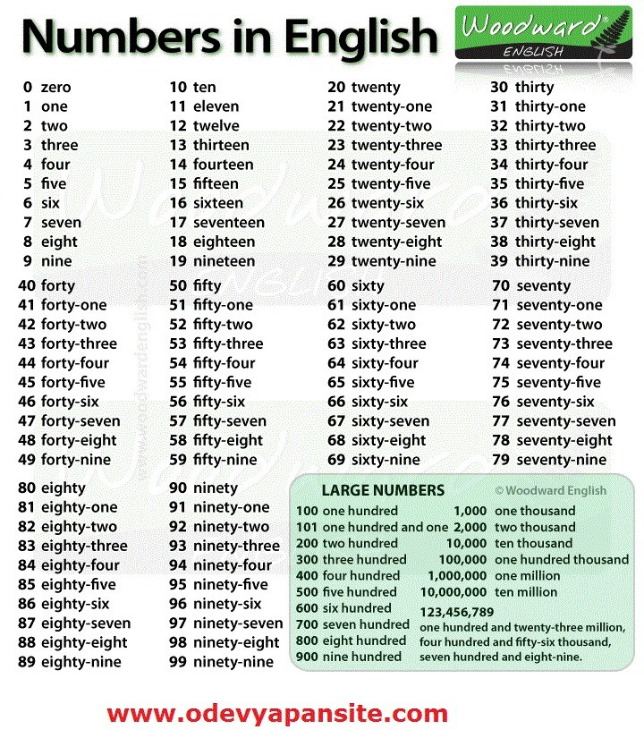

İNGİLİZCE DERSİ 9. SINIF 1. ÜNİTE WORKSHEET
A. Write in the correct Verb to be (am-is-are) (10x1=10p.)
- Cindy ______ my best friend.
- Peter and Kate ______ classmates.
- ________Johnny your brother?
- _______you a good student?
- They ______ in the classroom.
- _______this an apple?
- Felicia and I ______ sisters.
- I _____ her teacher.
- Those _______ my schoolbags
- Their father _______ a doctor.

C. Fill in the blanks with the correct po ssessive adjectives (my, your, his, her, ıts, our, their). (12x1=12p.)
- Hello. I’m Tina. This is _____ mother. _____ name is Betty.
- They are sisters. _______ names are Hale and Jale.
- Are you John? Is this _______ book?
- Steve is here. These are ________books.
- Orhan and I are brothers and this is ____ house.
- _____names are Frank and George. We are doctors.
- You are a teacher and _______ class is 11A.
- This is our car. ________color is blue.
- My favorite pop stars are Noel and Liam. I think _______ music is great.
- A: Who’s _______ favorite pop star?
B: _______ favorite pop star is Mustafa Sandal.

D. Write the numbers in words. (5x1=5p.)
12:
30:
60:
99:
55:
E. Write the words in numbers. (5x1=5p.)
Twenty-two:
Seven :
Seventy :
Forty-nine :
Nineteen :

F. Write the countries or the nationalities (5x1=5p.)
COUNTRY NATIONALITY
1. The USA ______________________
2. Spain ______________________
3. ______________ English
4. ______________ Chinese
5. Greece ______________________
G. Match the jobs with the explanations. (8x1=8p.)
___1)A baker a) designs buildings.
__ 2) A florist b) catch the criminals.
__ 3) A mechanic c) helps people while they’re shopping.
___4) An architect d) makes bread.
__ 5) A shop assistant e) sells flowers
___6) A writer f) is the assistant to the boss.
___7) A secretary g) writes books.
___8) A policeman h) repairs cars.

H. Use have got or has got (5x1=5p.)
1. I______________ 5 English classes a week.
2. My brother______________ a new book.
3. My father______________ a lot of tools.
4. George and Mary ______________ a new flat.
5. Our school ______________ a big garden.

I. Fill in the blanks with the correct family members (5x2=10p.)
- My mother’s husband is my __________________
- My sister’s mother is my ____________________
- My father’s sister is my _____________________
- My brother’s sister is my _____________________
- My uncle’s son is my ________________________

J. Look at the map and answer the questions (5x2=10p.)
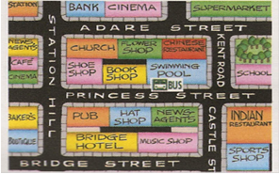
Here.
1. Where is the book shop?

2. Go straight ahead. Take the second turning on the right. Go past the pub. It is on the right…………………

3. Where is the flower shop?

4. Go straight ahead. Take the second turning on the right Go past the bookshop. It is on the left …………………
5. Where is the baker’s?

K. Write five sentences about yourself (5x2=10p.)

